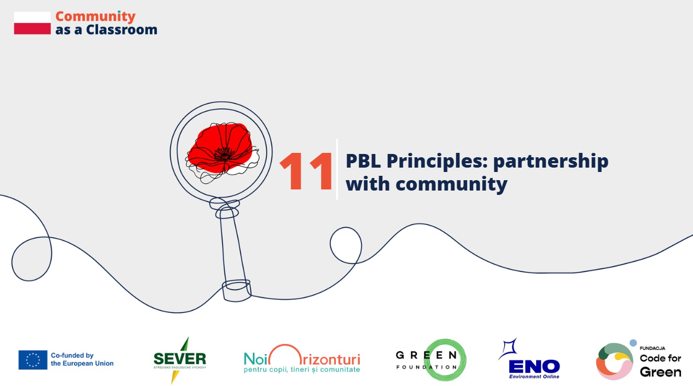
Country: Poland
Schools: Primary School no.5 in Zabrze, Primary School no.26 in Zabrze, Primary School no.31 in Zabrze
Contributors: local activists, teachers, headteachers
Community as a learning partner
Marlena Małek-Błaszczyk, the initiator of the community garden in Zabrze:
Do you see the point of working with young people?
Absolutely. Especially now, the intergenerational exchange of knowledge is interesting because the pace of technological progress is so fast, both older and younger people can learn from each other.
What did you gain from working with young people?
I feel I'm constantly learning, because young people really have a completely different perspective than more mature people, so you can always learn something new from them.
Learning from experts and local partners
Małgorzata Krakowczyk, teacher at Primary School no.5 in Zabrze: First and foremost, I value building new relationships. Students meet peers who, like them, are involved in similar environmental initiatives. This gives them a mutual feeling of motivation and confidence that what they are doing is good and meaningful. Students gain new knowledge not from textbooks, but from experts and local authorities, realizing that together, as a group, they can achieve a lot.
Sylwia Kot, the headteacher of Primary School no.26 in Zabrze: Our school is a school with long tradition. We have existed for 110 years here in the Mikulczyce district of Zabrze. We are not just an educational institution, but a center for local community life.
We try to encourage them to build relationships with us through cooperation with other institutions with which we carry out various projects. Among them, it is worth mentioning the municipal library of Zabrze, the botanical garden, the MOPR - the Municipal Family Support Center, we also work closely with the District Council.
We organize not only projects but also events, like fairs or Christmas dinners for people with disabilities. We also cooperate with the University of Silesia in Katowice, creating educational projects that broaden the educational perspective for our students.
Our school also works with local businesses that share our values and want to help us grow. Our school shows that partnership is an important step in the development of both children and schools.
Building networks through environmental projects
Małgorzata Krakowczyk, teacher at Primary School no.5 in Zabrze: Our school regularly takes part in both local and international environmental projects. We started with the “Dotknij nauki” ("Touch the Science") project, then “Make it Open,” and annual local initiatives like “Zobacz płuca” ("See the Lungs") and “Naturalnie w Zabrzu“ ("Naturally in Zabrze".) Through participation in such initiatives, I made connections with people who introduced me to the Erasmus+ “Community as a Classroom” project. I found this initiative very appealing and decided to take part.
Partnership develops responsibility and agency
Katarzyna Krulicka, Primary School no. 31 in Zabrze: Education does not happen in isolation. Thanks to the Place-Based Learning technique, we have all learned that. Our students, through collaboration with local institutions like the University of Silesia in Katowice, have learned responsibility, agency, and collaboration skills.
Funded by the European Union. Views and opinions expressed are however those of the author(s) only and do not necessarily reflect those of the European Union or the granting authority. Neither the European Union nor the granting authority can be held responsible for them.

