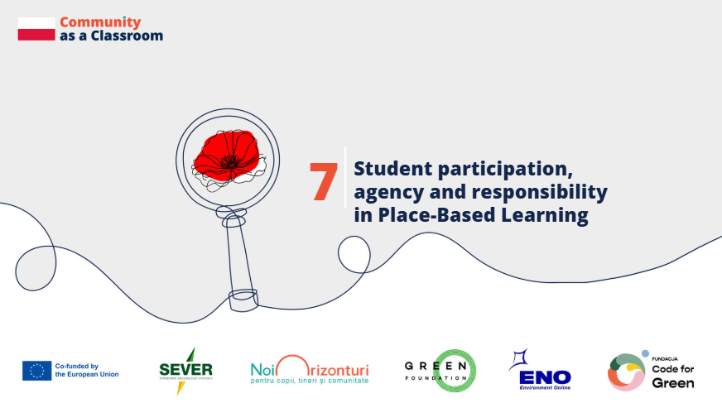
Country: Poland
Schools: SP nr 31 in Zabrze and IV LO in Zabrze, Poland
Voices: teachers, students and PBL expert from Code for Green
Why is participation important in PBL?
Participation in Place-Based Learning means more than simply engaging students in activities. It means giving them agency – the opportunity to influence what they learn, choose the issues they want to explore and take responsibility for their own learning.
Katarzyna Krulicka, Polish teacher, SP nr 31 in Zabrze: “Participation is more than engagement, it’s agency. Giving students a voice liberates education and builds community.”
How do students experience having a real choice?
Students from IV LO in Zabrze reflected on how it felt to decide what they wanted to learn and work on.
,,Well, I definitely felt responsible, because in the workshop I could bring up a topic that we don’t usually discuss at school, because, for example, the curriculum doesn’t cover it or we don’t have the time. And that’s also why I felt that way — because all the knowledge I shared stayed in others’ minds.”
,,I felt good, because finally someone took my opinion to heart, and that I could finally learn about things I wanted to know, and what I always wanted to study.”
,,I felt like I had the opportunity to choose, and I could decide for myself, what I wanted to learn, what I wanted to study, what I wanted to explain, what I wanted to talk about. And it just felt really good that I could simply choose. And I felt appreciated — that as a student I could teach someone how to research and take care of nature. I feel good knowing I was able to do that.”

From students to experts in their community
An important moment came when students organised workshops for local residents and shared the results of their work.
Anna Foltyn-Simka, chemistry teacher, IV LO in Zabrze: “I think what will stay with us the longest is the memory of those workshops we conducted for the residents. We were very nervous, wondering if we could make it work, if anyone would come, if anyone would want to listen to you – young people who carried out research.”
The experience changed the students’ perception of their own role: “You might have thought: ‘What do we know? We don’t have any experience yet, we’re not experts.’ But you became experts for those residents. I think that really boosted your confidence and will stay with you for a long time.”

What is the teacher’s role?
Authentic participation requires a different role for the teacher. Instead of determining every step, the teacher creates conditions in which students can identify issues that matter to them and choose how they want to address them.
Małgorzata Wójcik-Dudek, lecturer, Code for Green: “To speak of authentic participation in PBL and of authentic engagement with space, students must feel that the problem and the space matter to them, and that the engagement arises from a genuine, real experience of the place where students learn, live, and for which they want to be responsible. To feel responsible for their space, they must identify a problem — a local problem —to solve. Of course, the teacher can support them in this search, but the teacher should never be the leader. They can draw attention, suggest things, but the choice must always be made by the student. The teacher is also responsible for creating a friendly atmosphere filled with educational tools — which should not be imposed either, but rather chosen by the students themselves, matching those tools to both the local issue and their own sensitivity and capacity for agency. The teacher should never be the leader, but should create an atmosphere of openness, care, friendship, and engagement, as well as attentiveness to all the ideas, students bring to the project.”

What changed?
Giving students greater autonomy had a visible effect on their motivation and curiosity.
Anna Foltyn-Simka: “You know, while observing students at work, I saw their smiles, energy, and the fact that because it was them who decided what to do, it increased their curiosity. We did more than we even planned to do. Whenever we went on a trip, they always wanted to test this water, that water… It’s such a wonderful feeling for a teacher, for someone guiding them, to see that by giving them a bit of space, they used all of it to its full potential. I’m truly happy that they were so active, enthusiastic, and engaged in this project.”

Key message for other schools
Katarzyna Krulicka: “Participation is not just a method – it’s a way of thinking and learning. Students who take responsibility for their learning are also leaders in their communities. So let students act – and see what they can achieve.”

Funded by the European Union. Views and opinions expressed are however those of the author(s) only and do not necessarily reflect those of the European Union or the granting authority. Neither the European Union nor the granting authority can be held responsible for them.

