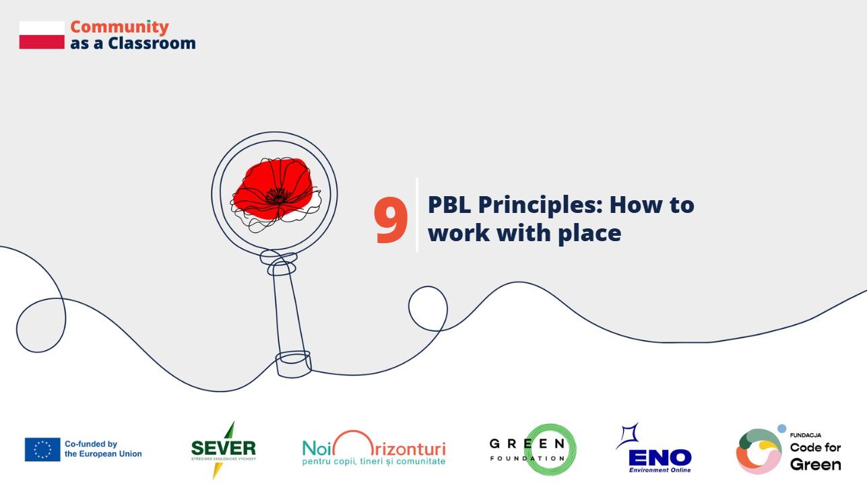

Country: Poland
Schools: Primary School no.5 in Zabrze, Primary School no.26 in Zabrze, Primary School no.31 in Zabrze
Contributors: teachers, students, local activists
Place as a starting point for meaningful learning
Małgorzata Krakowczyk, teacher at Primary School no.5 in Zabrze: A place is more than just a backdrop. It’s a space where learning becomes reality. Working in a place students know helps develop a sense of belonging and civic responsibility in students.
Understanding the history and identity of a place
Marlena Malek-Blaszczyk, the initiator of the community garden in Zabrze:
Why is it important for young people to learn about the place they live in?
I think it's important because everyone should know the history of where they live, their roots. It's important because the way a place looks now results from the processes that took place here in the past. Such knowledge teaches us to think about how the world works and how such processes also happen elsewhere.

Learning from local stories and personal memories
Magdalena Gościniak, forest activist in Zabrze: What stories, what knowledge should be passed on to young people? Honest, true, not made-up, but the kind we've gathered partly through stories, partly through local history. Not the grand, political one written somewhere high above, but the one that’s close, personal. In the stories of grandparents, uncles, aunts, neighbors.
When the place becomes a learning resource
Agnieszka Kedzierska-Lemańska, teacher at Primary School no.26 in Zabrze: During the project, we didn’t need books or textbooks because we went out to the ponds with our students. We went to the shore of something they described with words and images. We took photos, then painted pictures, wrote poems. From these works, we created our little book, which we're very proud of, and the students are too, because this is a tangible proof of the project's successful conclusion.
This is something that will stay with them for a long time, something they can be proud of, and something that they can really keep for the rest of their lives somewhere on their shelf and they'll remember that they took part in such a cool project.
Ewa Dunajewska-Ozimek, teacher at Primary School no.31 in Zabrze: Thanks to participating in many projects, students above all felt that they can take action the effects of which are felt not only in their neighborhood, where they live, but also in the entire city.
Building agency through connection with place and community
Małgorzata Krakowczyk, teacher at Primary School no.5 in Zabrze: Teachers should help their students understand the value of the place where they live. where they live. People often praise what's far away, they long for things that are unknown to them, and fail to notice many beautiful places around them.
Thanks to such projects, students get to know their surroundings and start to notice its beauty. By talking to experts who care about a sustainable environment, they experience a sense of certainty that there are more people who care about a naturally functioning ecosystem.
Through conversations with the local community, they feel they have agency. Giving students agency, allowing them to truly make decisions about their own actions and choices undoubtedly helps build citizens who are aware of their own values.

Funded by the European Union. Views and opinions expressed are however those of the author(s) only and do not necessarily reflect those of the European Union or the granting authority. Neither the European Union nor the granting authority can be held responsible for them.

